Graded Unit Test Data and Log
Java and JDBC prepared statement Test Plan
Where the ? goes in the program(part that is going to be complete by user with the UI) I put a 0 for testing purpose
Test No. | Test Data | Result | Pass/Fail | Comments
1 | INSERT INTO clients VALUES(0,0,0,0) | 100 % the query works | Pass
2 | SELECT * FROM clients WHERE client_id=0 | 65 % the query can be improved | Pass | This query can be improved but it is going to work
3 | SELECT * FROM orders WHERE order_id=0 | 65 % the query can be improved | Pass | This query can be improved but it is going to work
4 | INSERT INTO ordered products VALUES(0,0,0) | 100 % the query works | Pass | Changed to this later with DB TEST  INSERT INTO `ordered products` VALUES(0,(SELECT order_id FROM orders WHERE order_id=0),(SELECT product_name FROM products WHERE product_name=0))
5 | INSERT INTO orders VALUES(0,0,sysdata) | 100 % the query works | Pass
6 | SELECT quantity FROM product WHERE product_name=0 | 65 % the query can be improved | Pass | This query can be improved but it is going to work
7 | INSERT INTO  products  VALUES  (0, 0, 0, 0, 0, 0) ON DUPLICATE KEY  UPDATE  quantity = quantity + 0; | 100 % the query works | Pass
8 | UPDATE products SET quantity=quantity-0 WHERE product_name=0 | 100 % the query works | Pass
9 | INSERT INTO suppliers VALUES(0,0,0,0) | 100 % the query works | Pass
10 | SELECT * FROM suppliers WHERE supplier_id=0 | 65 % the query can be improved | Pass | This query can be improved but it is going to work
11 | SELECT * FROM orders WHERE ordersdate=CURRENT_DATE-7 | 65 % the query can be improved | Pass | This query can be improved but it is going to work
12 | SELECT * FROM orders WHERE ordersdate=CURRENT_DATE-30 | 65 % the query can be improved | Pass | This query can be improved but it is going to work
13 | INSERT INTO new_stocks VALUES(0,0,0) | 100 % the query works | Pass | Later changed to  INSERT INTO `new stocks` VALUES(3,(SELECT product_name FROM products WHERE product_name="onions"),(SELECT supplier_id FROM suppliers WHERE supplier_id=1))

PhpMyAdmin and MySQL Server Testing
Test No. | Test Data | Result | Pass/Fail | Comments
1 | SELECT * FROM clients | The query works | Pass
2 | SELECT * FROM orders | The query works | Pass
3 | SELECT * FROM ordered products | The query works | Pass
4 | SELECT * FROM products | The query works | Pass
5 | SELECT * FROM new stocks | The query works | Pass
6 | SELECT * FROM suppliers | The query works | Pass
7 | INSERT INTO clients VALUES(1,”Veggie Shop”,”veggie.shop@gmail.com”,”+4400000000”) | The query works and the clients get added to the table | Pass
8 | INSERT INTO orders VALUES(1,1,CURRENT_DATE) | The query works and the orders get added to the table | Pass
9 | INSERT INTO `ordered products` VALUES(3,1,”onions”) | The query does not works | Fail | I changed the queries in the program and the DB test to this  INSERT INTO `ordered products` VALUES(3,(SELECT order_id FROM orders WHERE order_id=1),(SELECT product_name FROM products WHERE product_name="onions"))
10 | INSERT INTO products VALUES("onions","red onions","UK",0.20,3,1) | The query works and the orders get added to the table | Pass
11 | INSERT INTO new stock VALUES(3,1,”onions”) | The query does not work | Fail | Changed to this  INSERT INTO `new stocks` VALUES(3,(SELECT product_name FROM products WHERE product_name="onions"),(SELECT supplier_id FROM suppliers WHERE supplier_id=1))
12 | INSERT INTO suppliers VALUES(1,"Suppliers of Veggie","veggie.suppliers@gmail.com","+44111111111") | The Query works and a supplier get added to the DB | Pass
13 | UPDATE clients SET company_name= 'veg shop' WHERE client_id=1 | The queries work and it get updated | Pass
14 | UPDATE orders SET order_id=2 WHERE order_id=1 | The MySQL statement doesn’t work | Fail | You cant update the orderd id because is a foreign key in other table
15 | UPDATE ordered products SET order_id=2 WHERE order_id=1 | The MySQL statement doesn’t work | Fail | You cant update the orderd id because is a foreign key in other table
16 | UPDATE products SET description= 'Red onion from Essex' WHERE product_name= 'onions' | The statement works and the description get updated | Pass
17 | UPDATE `new stocks` SET quantity=4 WHERE supplier_id=1 | The Statement works and the quantity get updated | Pass
18 | UPDATE suppliers SET supplier_name="fruit supplier" WHERE supplier_id=2 | The Statement works and the supplier name get updated | Pass
19 | DELETE FROM clients WHERE client_id=1 | Cant delete because there is a foreign key | Fail | It’s not really important for the program
20 | DELETE FROM orders WHERE order_id=2 | Cant delete because there is a foreign key | Fail | It’s not really important for the program
21 | DELETE FROM ordered products WHERE order_id=2 | Cant delete because there is a foreign key | Fail | It’s not really important for the program
22 | DELETE FROM products WHERE product_name= “onions“ | Cant delete because there is a foreign key | Fail | It’s not really important for the program
23 | DELETE FROM new stocks WHERE supplier_id=1 | Cant delete because there is a foreign key | Fail | It’s not really important for the program
24 | DELETE FROM suppliers WHERE supplier_id=1 | Cant delete because there is a foreign key | Fail | It’s not really important for the program

GUI Testing
Test No. | Test Data | Result | Pass/Fail | Comments
1 |  | The GUI does what is suppose to and get to the next window | Pass
2 |  | The GUI does what is suppose to and get to the next window | Pass
3 |  | The GUI does what is suppose to and get to the next window | Pass
4 |  | The GUI does what is suppose to and get to the next window | Pass
5 |  | The GUI does what is suppose to and get to the next window | Pass | The Window show ups tinier that expected and need to be open up by the user
6 |  | Then radio button select the right radio button | Pass
7 |  | Then radio button select the right radio button | Pass
8 | veggie.shop@gmail.com | The textfield accept the data | Pass
9 | Veggie Shop | The textfield accept the data | Pass
10 | +4400000000 | The textfield accept the data | Pass
11 |  | The button works and get to the new page | Pass | The Window show ups tinier that expected and need to be open up by the user
12 |  | The radio button blocked and unblocked the right textfield | Pass
13 |  | The radio button blocked and unblocked the right textfield | Pass
14 | 1 | The textfield accept the data | Pass
15 | onions | The textfield accept the data | Pass
16 | 0.20 | The textfield accept the data | Pass
17 | UK | The textfield accept the data | Pass
18 | Red onions from Essex | The textfield accept the data | Pass
19 | 3 | The textfield accept the data | Pass
20 |  | The radio button gets selected | Pass
21 |  | The radio button gets selected | Pass
22 |  | The add button empty all the right textfield/radio button | Pass
23 |  | The button work, and the app shut | Pass
24 |  | The radio button click and select and unselect in the right way | Pass
25 |  | The radio button click and select and unselect in the right way | Pass
26 |  | The radio button click and select and unselect in the right way | Pass
27 | 1 | The textfield accept the data | Pass
28 |  | The button work, and the app shows the textbox | Pass
29 |  | The button works | Pass
30 |  | The button work, and the app shows the textbox | Pass

“5 a Day” Program Test
Test No. | Test Data | Result | Pass/Fail | Comments
1 |  | The program runs | Pass
2 |  | The connection get established | Pass
3 |  | The button works | Pass
4 |  | The button works | Pass
5 |  | The button works | Pass
6 |  | The button works | Pass
7 |  | The button works | Pass
8 | Company Name:Veggie buyer  Email:veggie.buyer@gmail.com  Phone number:+44000000000 | The client get added | Pass
9 | Company Name:Fruit buyer  Email:fruit.buyer@gmail.com  Phone number: +4411111111 | The client get added | Pass
10 | Company Name:Veggie fanatics  Email:fanaticsforveggie@gmail.com  Phone number:+4422222222 | The client get added | Pass | This is the DB after adding of the data  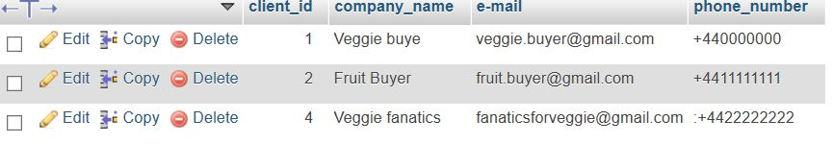
11 | Company Name:Veggie Supplier  Email:supplier.veggie@gmail.com  Phone number:+4433333333 | The supplier get added | Pass
12 | Company Name:Fruit Supplier  Email:supplier.fruit@gmail.com  Phone number:+4444444444 | The supplier get Added | Pass
13 | Company Name:5 a day supplier  Email:supplier5aday@gmail.com  Phone number:+4455555555 | The supplier get added | Pass | This is the DB after adding data  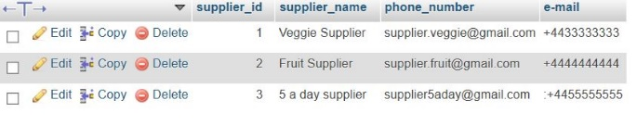
14 | Product Name:Onions  Quantity:5  Price:0.20  Provenance:UK  Description:Red onions  Type:Veggie  Supplier:2 | The New  Stock get  added | Pass
15 | Product Name:Apple  Quantity:10  Price:0.25  Provenance: Spain  Description:Red gala  Type:Fruit  Supplier:2 | The New  Stock get  added | Pass
16 | Product Name:Tomato  Quantity:15  Price:0.10  Provenance: Italy  Description: Red Cherry tomato  Type:Veggie  Supplier:3 | The New  Stock get  added | Pass | New Stocks and product table in the db  after the test  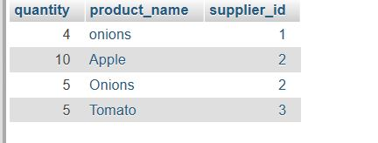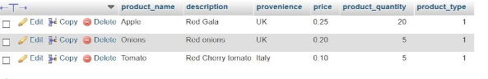
17 | Product Name:Tomato  Quantity :1  Client ID:1 | The product didn’t get added to the order | Fail (pass) | I ran some test before that I didn’t write down , and I left the tomato quantity to 3 , so that wasn’t able to get retrieve from the database , So technically it pass another feature, the order was added empty
18 | Product Name: Apple  Quantity:1  ClientID:3 | The product was added to the order | Pass
19 | Product Name: Pear  Quantity: 1  ClientID: 2 | The product was added to the order | Pass | DB after the three order(I did some untraced test before)  Ordered products table(the tomato are from another order I did before)  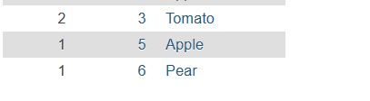  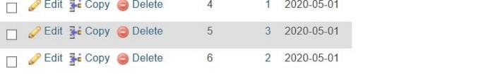
20 | Stock 1:Pinapple,20,1.20,Colombia,not for Pizza,Fruit, 2  2: Mango,10,0.90,Uruguay,Fresh mango,Fruit,2  3:Papaya,5,2.00,Brazil,Fresh Papaya,Fruit ,2 | The new stock get added correctly to the system | Pass | New Stock  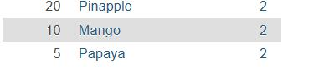  Products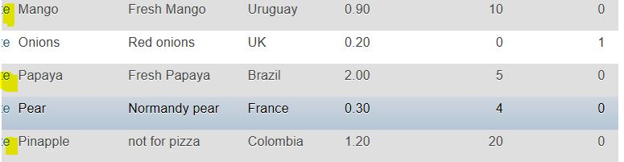
21 | Stock  1: Kali , 10,0.30,UK,Kali from Wales,Veggie,1  2:Broccoli,20,0.50,UK,Fresh Broccoli from Northumbria,Veggie , 1  3:Courgette,30,1.10,UK,Courgette from Essex,Veggie,1 | The new stock get added correctly to the system | Pass | New Stock  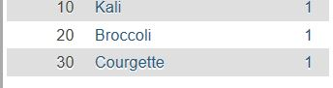  Products  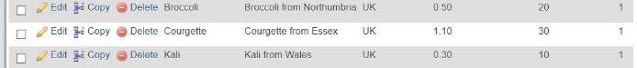
22 | Stock  Apple,10,3(same as last stock,still need to enter some information on textfield)  Tomato,10,3(same as last stock)  Potato,10,1, Ireland,golden potato,veggie,3 | The new stock get added but you still have to put something of the right type on the textfield even if the product is already in the system | Pass/fail | New Stocks  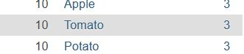  Products  In the feature there should be a possibility that if the text field is empty to send something that make the function work, since it does not matter because is not going to be added to the system
23 | Order Client ID 2  Products: Mango 3, Papaya 1, Kali 3, Broccoli 1 | The Program add the order in the right way | Pass | Ordered items  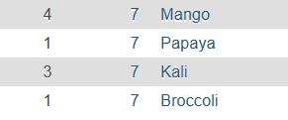  Orders
24 | Order Client ID 1  Products: Apple 4, Potato 3, Tomato 2 | The Program add the order in the right way | Pass | Ordered items  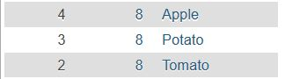  Order
25 | Order Client ID 3  Products: Pear 5(shouldnt be added), Courgette 10,Kali 5,Pinapple 2 | The pear get added to the order even if that number is more then the one available | Fail | This feature needs to be added in the next implementation  Ordered Items  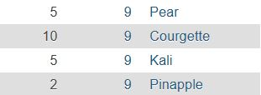  Order
26 | Client Id 1 | The Info are displayed | Pass | 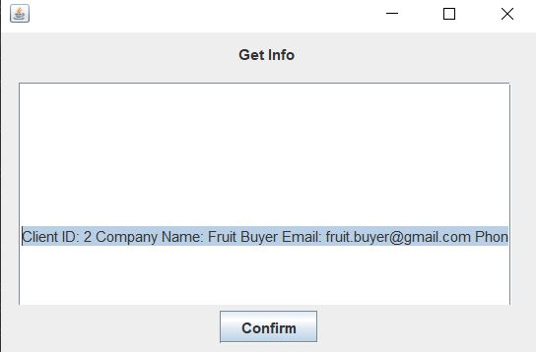
27 | Client Id 2 | The Info are displayed | Pass | 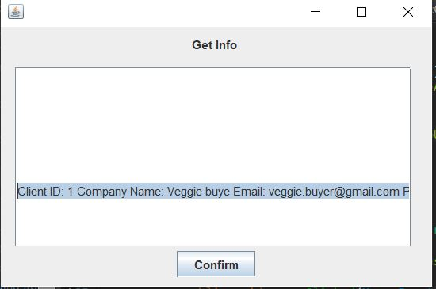
28 | Client Id 3 | The Info arent displayed | Fail | There is no Client number 3
29 | Supplier Id 1 | The Info are displayed | Pass | 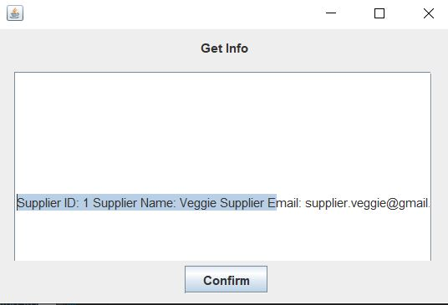
30 | Supplier Id 2 | The Info are displayed | Pass | 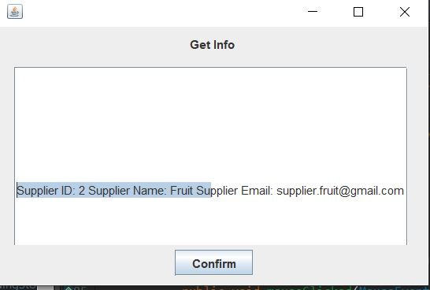
31 | Supplier Id 3 | The Info are displayed | Pass | 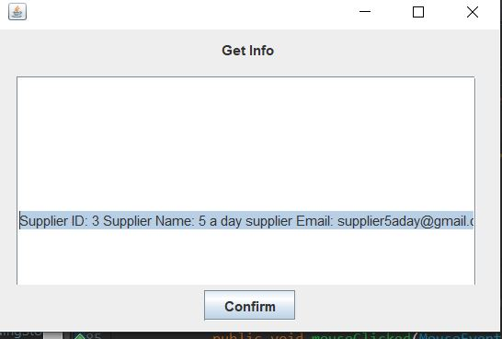
32 | Order ID 4 | The Info are displayed | Pass | 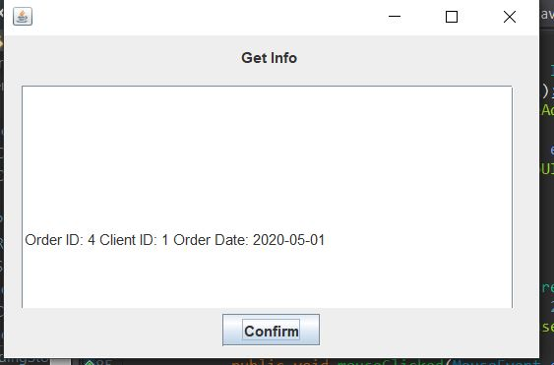
33 | Order ID 6 | The Info are displayed | Pass | 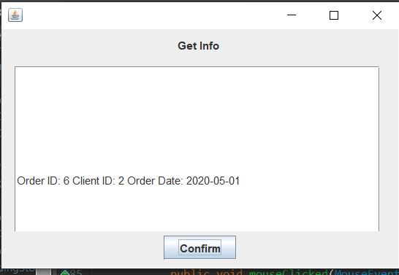
34 | Order ID 8 | The Info are displayed | Pass | 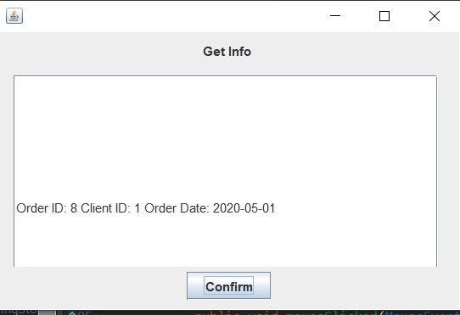
35 |  | Nothing is displayed | Fail | The feature does not work
36 |  | Nothing is displayed | Fail | The feature does not work

